**DAILY ONLINE ACTIVITIES SUMMARY**

|  |  |  |  |  |  |  |  |  |
| --- | --- | --- | --- | --- | --- | --- | --- | --- |
| **Date:** | **26 June 2020** | | | | | **Name:** | **K. ISHA HEGDE** | |
| **Sem & Sec** | **4th sem, 2nd year** | | | | | **USN:** | **4al18cs031** | |
| **Online Test Summary** | | | | | | | | |
| **Subject** | | **------** | | | | | | |
| **Max. Marks** | | **----** | | **Score** | | | **---** | |
| **Certification Course Summary** | | | | | | | | |
| **Course** | **INTRODUCTION TO DIGITAL MARKETING** | | | | | | | |
| **Certificate Provider** | | | **Google garage** | | **Duration** | | | **3hours** |
| **Coding Challenges** | | | | | | | | |
| **Problem Statement:2 program** | | | | | | | | |
| **Status: Executed** | | | | | | | | |
| **Uploaded the report in Github** | | | | | **Yes** | | | |
| **If yes Repository name** | | | | | <https://github.com/iishaii/locked-down_coding> | | | |
| **Uploaded the report in slack** | | | | | **Yes** | | | |

#### *Certification Course Summary:*

Today I continued with INTRODUCTION TO DIGITAL MARKETING from google garage which is of 40 hrs. After the completion of course, certificate will be provided.



***Coding Challenges:***

Today I solved 2 coding challenge,

1. **Given start and end of a range, write a Python program to print all negative numbers in given range.**

Example: Input: start = -4, end = 5 Output: -4, -3, -2, -1 Input: start = -3, end = 4 Output: -3, -2, -1

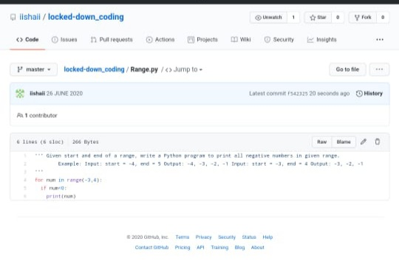

2.**Given an unsorted array arr [] of size N, rotate it by D elements (clockwise).**

**Input:**

First line of each test case contains two space separated elements, N denoting the size of the array and an integer D denoting the number size of the rotation. Subsequent line will be the N space separated array elements.

**Output:**

For each testcase, in a new line, output the rotated array.

**Constraints:**

1 <= T <= 200

1 <= N <= 107

1 <= D <= N

0 <= arr[i] <= 105

**Example:**

**Input:**

5 2

1 2 3 4 5

**output:**

3 4 5 1 2

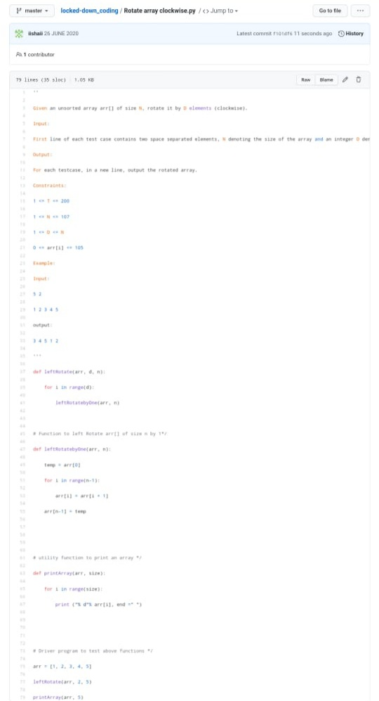

***Extra Activity:***

Today I attended Online training on Cyber security from morning

9:00-11:00Am. Two Quizzes are conducted.

